**DAILY ONLINE ACTIVITIES SUMMARY**

|  |  |  |  |  |  |  |  |  |
| --- | --- | --- | --- | --- | --- | --- | --- | --- |
| **Date:** | **29-06-2020** | | | | | **Name:** | **Rakesh M Kotian** | |
| **Sem & Sec** | **8 th sec-b** | | | | | **USN:** | **4al16cs072** | |
| **Online Test Summary** | | | | | | | | |
| **Subject** | | **sms** | | | | | | |
| **Max. Marks** | | **-** | | **Score** | | |  | |
| **Certification Course Summary** | | | | | | | | |
| **Course** | **Python for machine learning** | | | | | | | |
| **Certificate Provider** | | | **Great learning** | | **Duration** | | | **6 hours** |
| **Coding Challenges** | | | | | | | | |
| **Problem Statement:**  Array of vector | | | | | | | | |
| **Status:solved** | | | | | | | | |
| **Uploaded the report in Github** | | | | | **yes** | | | |
| **If yes Repository name** | | | | | **Rakeshkotian08** | | | |
| **Uploaded the report in slack** | | | | | **yes** | | | |

Online Test Details: (Attach the snapshot and briefly write the report for the same)

Certification Course Details: (Attach the snapshot and briefly write the report for the same)

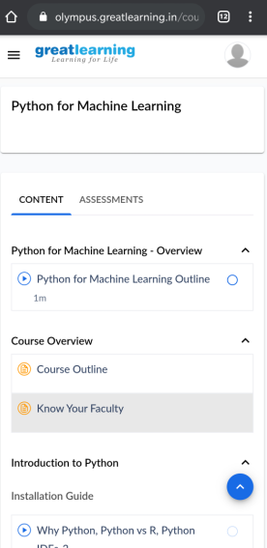

|  |  |  |
| --- | --- | --- |
| |  | | --- | | #include <iostream>  #include <vector>  using namespace std;    // Declaring array of vectors  // globally  vector<int> v[5];    // Function for inserting elements  // in array of vectors  void insertionInArrayOfVectors()  {        for (int i = 0; i < 5; i++) {            // Inserting elements at every          // row i using push_back()          // function in vector          for (int j = i + 1; j < 5; j++) {              v[i].push_back(j);          }      }  }    // Function to print elements in array  // of vectors  void printElements()  {        // Traversing of vectors v to print      // elements stored in it      for (int i = 0; i < 5; i++) {            cout << "Elements at index "               << i << ": ";            // Displaying element at each column,          // begin() is the starting iterator,          // end() is the ending iterator          for (auto it = v[i].begin();               it != v[i].end(); it++) {                // (*it) is used to get the              // value at iterator is              // pointing              cout << *it << ' ';          }          cout << endl;      }  }    // Function to illustrate array  // of vectors  void arrayOfVectors()  {      // Inserting elements in array      // of vectors      insertionInArrayOfVectors();        // Print elements stored in array      // of vectors      printElements();  }    // Driver code  int main()  {      arrayOfVectors();      return 0;  } |  |  | | --- | |  | |